Christopher Gonzalez
Professor Jennifer Holst
CSCI 401
28 April 2025
pwn.college Lab 5
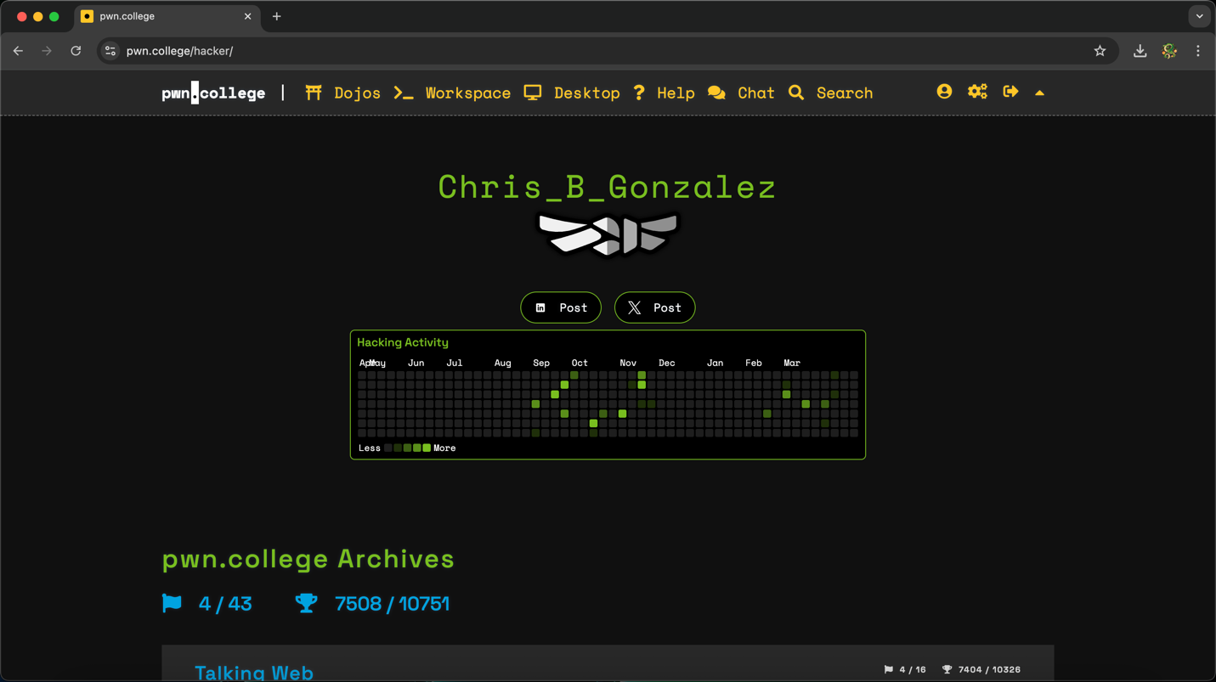

Challenge 1: level1
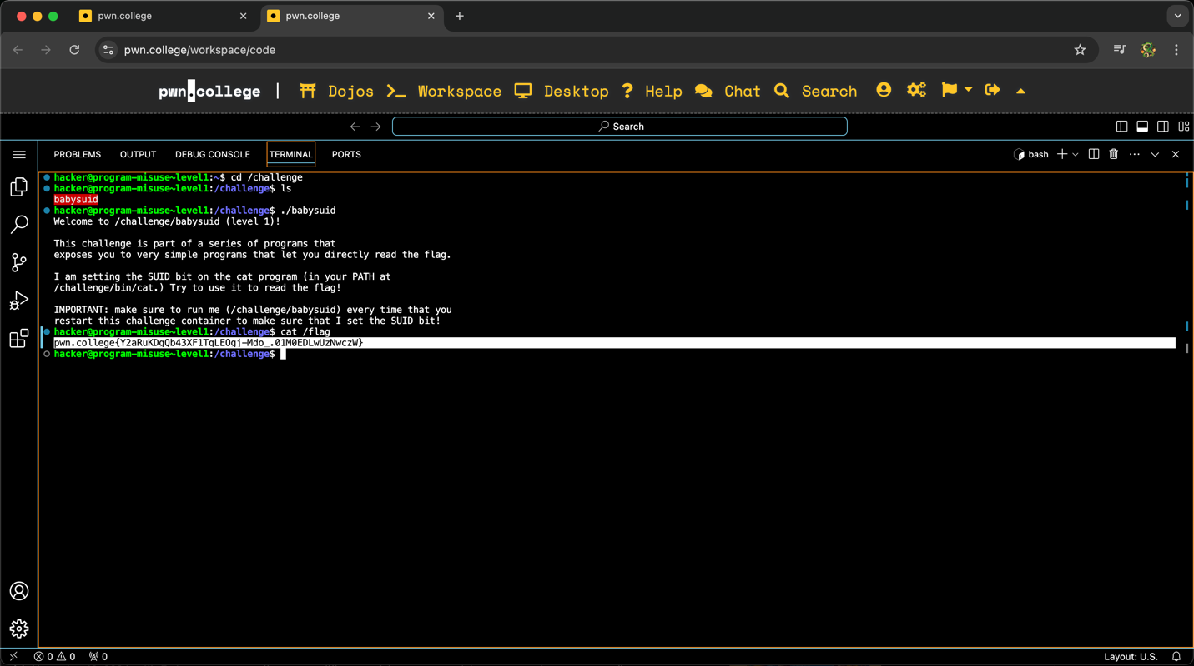
To obtain this flag, I started the challenge and opened the VSCode Workspace. The instructions for this set of challenges are short and direct to the point, where the objective is to simply read the flag. It took some time for me to figure out how to start the challenge. I started by going to the challenge directory by doing cd /challenge. Then I entered ls to see the program I needed to invoke to start the challenge which, was “babysuid”. Since I was already in the /challenge directory, I started the actual challenge by typing ./babysuid in the terminal. This started the program and offered additional information on how to get the flag. According to the welcome screen, I needed to read the flag which was stored in /challenge/bin/cat. I recognized the cat command and proceeded by going cat /flag, which worked.

Challenge 2: level2
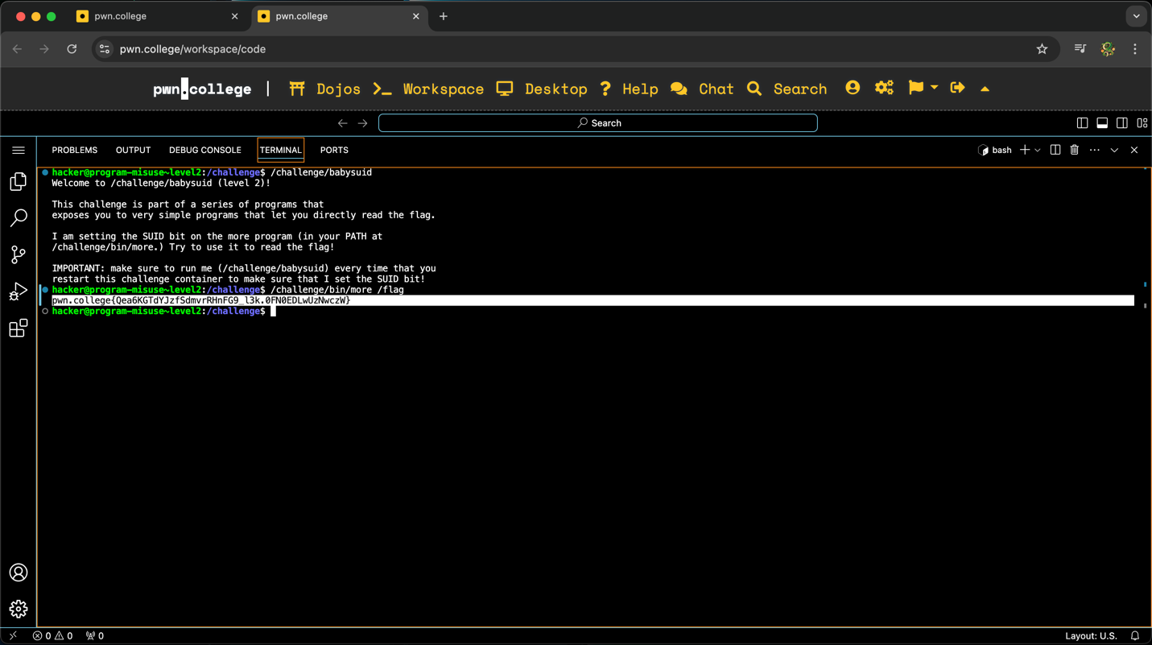
To obtain this flag, I started the challenge and opened the VSCode Workspace. In the previous challenge, I started by going to the /challenge directory, listing the directories in /challenge, and then go to the actual program. However, the welcome screen from the last challenge informed me that I can simply start the challenge by typing /challenge/babysuid, which is what I did. Like the previous challenge, this resulted in the welcome screen and the information that the flag was stored in /challenge/bin/more. Therefore, I typed /challenge/bin/more /flag, which resulted in the flag. The majority of these challenges are repetitive in the steps needed to obtain the flag, but the challenge does get more difficult later on.

Challenge 3: level3
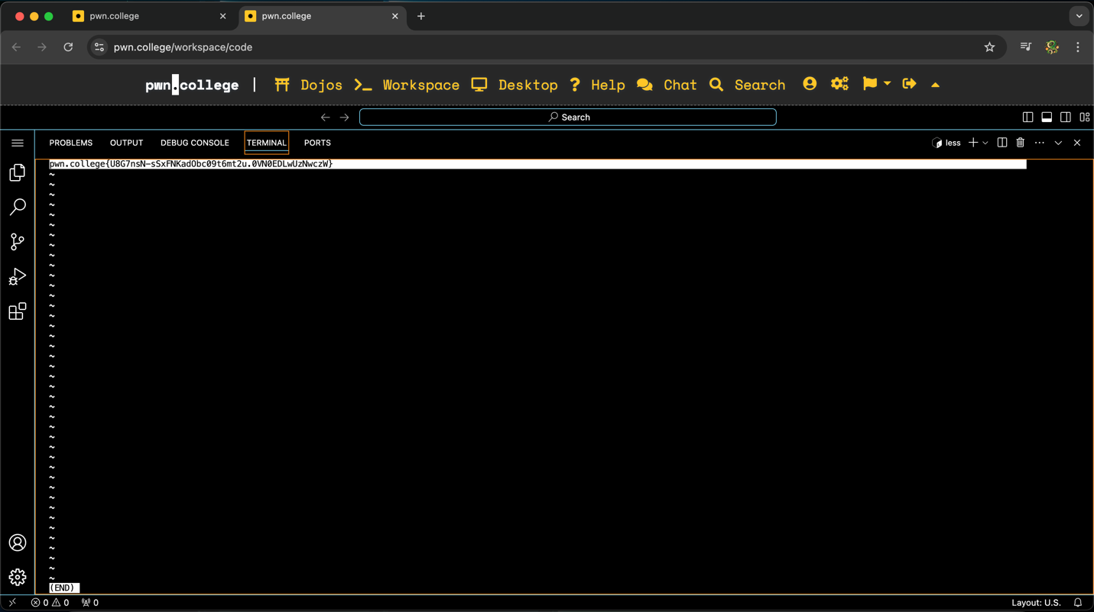
To obtain this flag, I started the challenge and opened the VSCode Workspace. Once I was in the terminal, I entered /challenge/babysuid to reach the welcome screen of this challenge. This time, the welcome screen informed me the flag was in the /challenge/bin/less directory. I proceeded by typing /challenge/bin/less /flag. This resulted in the terminal opening a text file with the flag information. Because of the nature of this challenge, I am unable to show the commands I entered and the flag at the same time. This will also be the case for three other challenges moving forward.

Challenge 4: level4
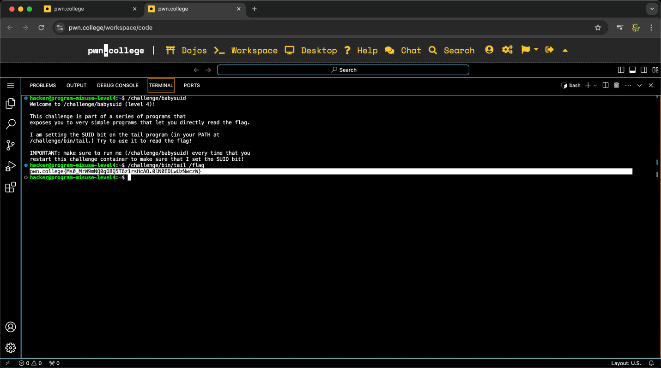
To obtain this flag, I started the challenge and opened the VSCode Workspace. After starting the challenge by entering /challenge/babysuid, the welcome screen informed me the flag was in the /challenge/bin/tail directory. Like the other challenges, I proceeded by entering /challenge/bin/tail /flag in the terminal, resulting in the capture.

Challenge 5: level5
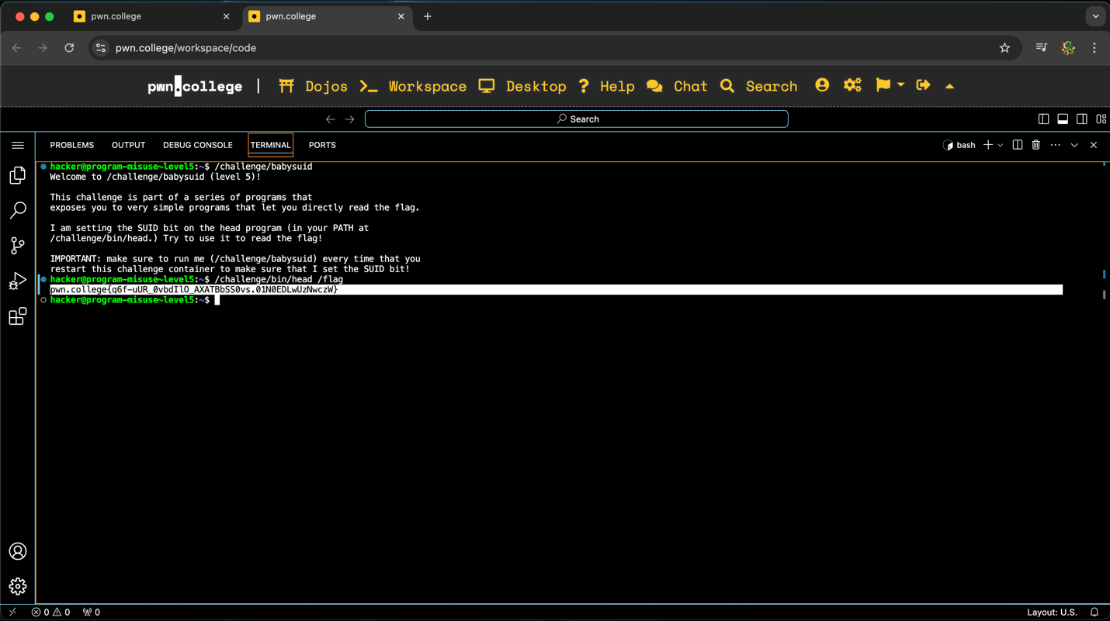
To obtain this flag, I started the challenge and opened the VSCode Workspace. The welcome screen for this challenge revealed the flag was in the /challenge/bin/head directory. This specific directory may have a special association with the directory seen in the last challenge (/challenge/bin/tail). I suspect to be the case because from my knowledge, head and tail are commands that allow the user to view the first/last 10 lines of a given file. If this challenge is supposed to reference this concept, this would imply the location in which the flag is stored is less than 10 lines (which would make sense since the flag only required 1 line). In the end, this resulted in the flag.

Challenge 6: level6
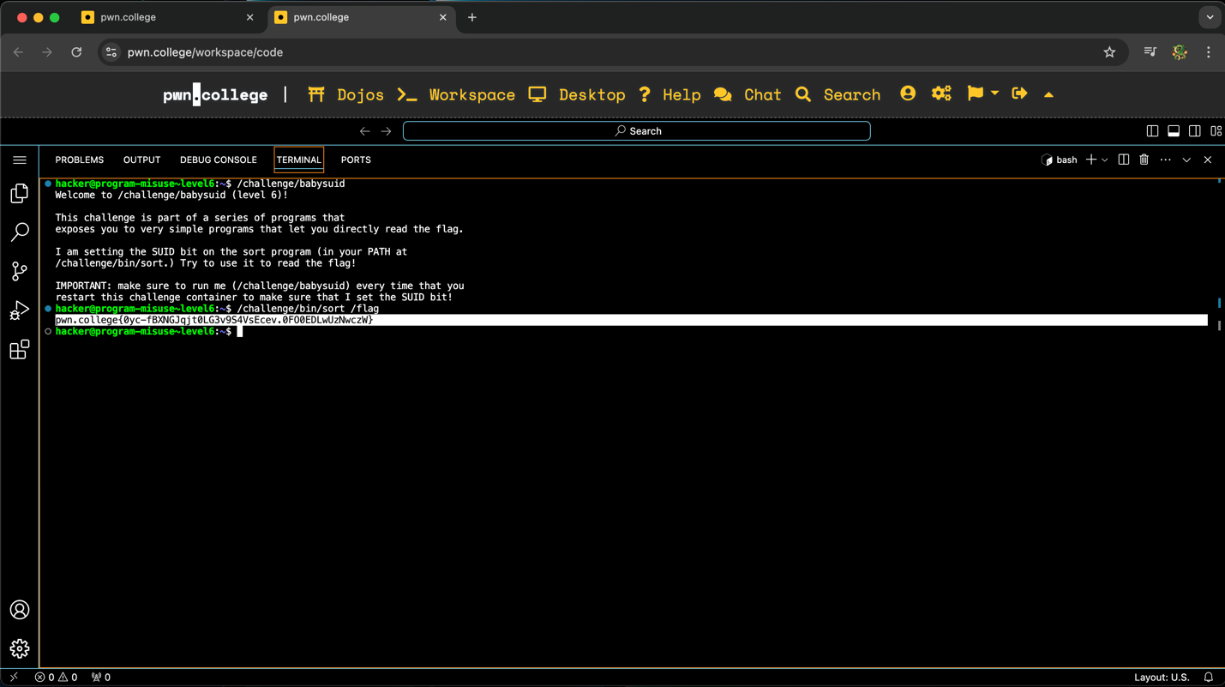
To obtain this flag, I started the challenge and opened the VSCode Workspace. After typing /challenge/babysuid in the terminal, the welcome screen revealed the flag was in the /challenge/bin/sort directory. It is at this point where I realized the last portion of the directories of these challenges (cat, head, tail, etc.) may be intentional and aimed to indirectly teach the users about commands that can be used in the terminal to perform operations. This aside, I proceeded with the challenge by typing /challenge/bin/sort /flag, which revealed the flag.

Challenge 7: level7
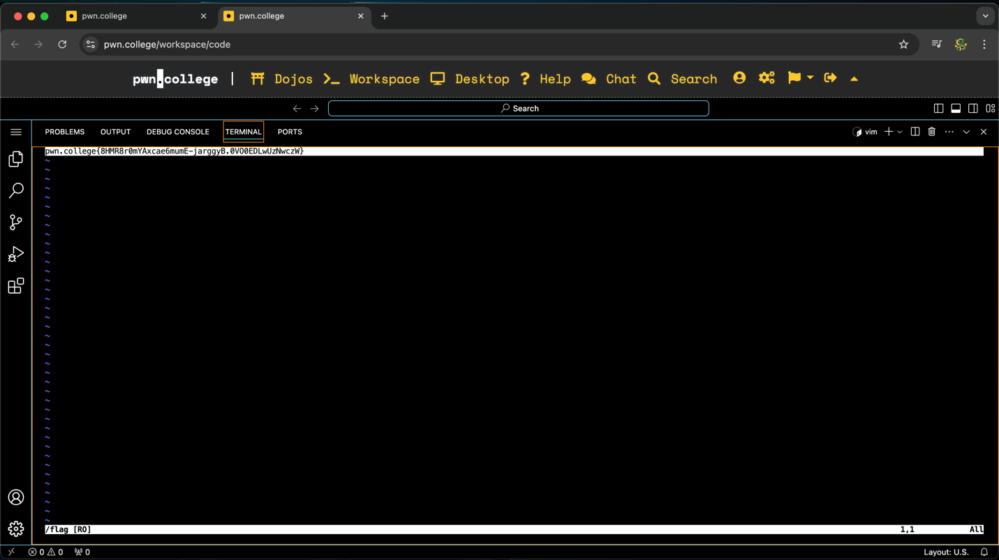
To obtain this flag, I started the challenge and opened the VSCode Workspace. Earlier in this document, it was stated that the nature of some challenges prevents me from acquiring a screenshot of the terminal showing the commands I used and the flag at the same time. The next three challenges are those scenarios. Like all the other challenges prior, I started by typing /challenge/babysuid in the terminal. The welcome screen for this challenge revealed to me the flag was in the /challenge/bin/vim directory. Thanks to my experience with other pwn.college challenges, I recognized the vim command. In short, vim is a command like cat that allows users to view the contents of a file. I proceeded by typing /challenge/bin/vim /flag, which opened the file that contained the flag information, as seen in the image above.

Challenge 8: level8
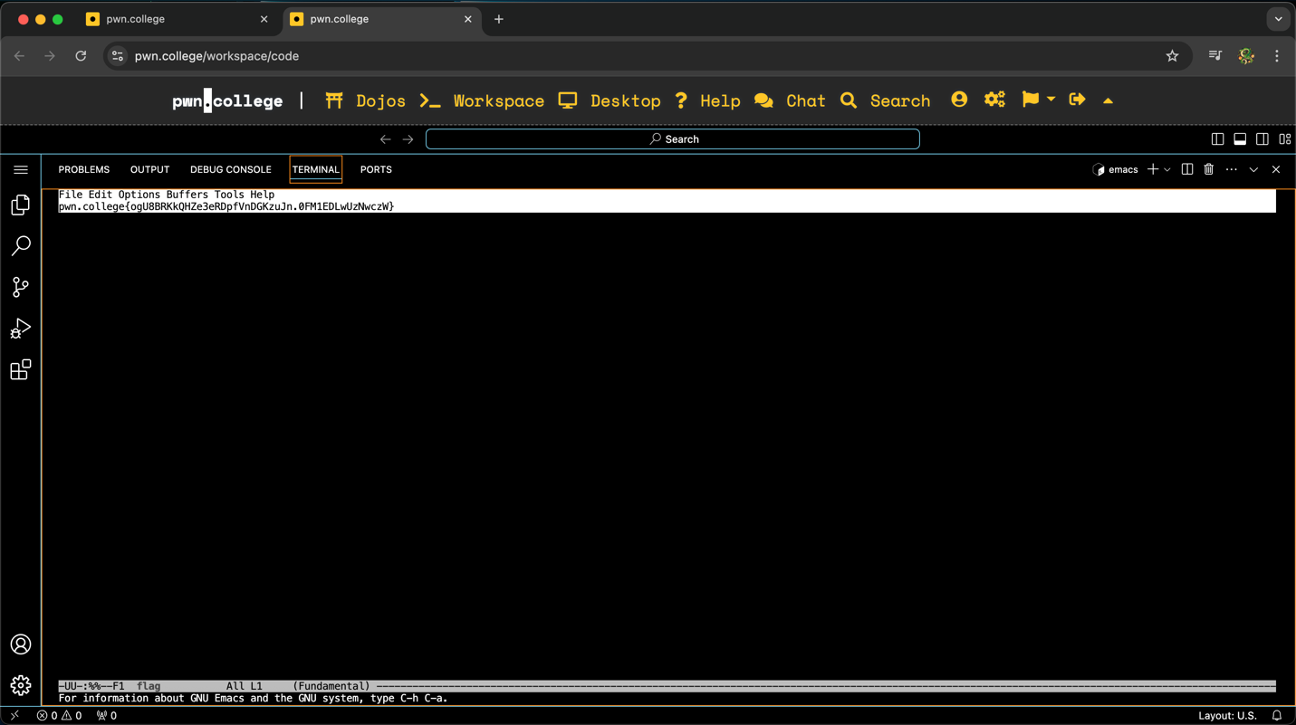
To obtain this flag, I started the challenge and opened the VSCode Workspace. After starting the program by entering /challenge/babysuid, the welcome page introduced me to the emacs command by informing me the flag was in the /challenge/bin/emacs directory. Through personal research, I learned emacs is a text-editing tool like vim (which was referenced in the last challenge). I proceeded by typing /challenge/bin/emacs /flag, which opened the file with the flag information just like the previous challenge.

Challenge 9: level9
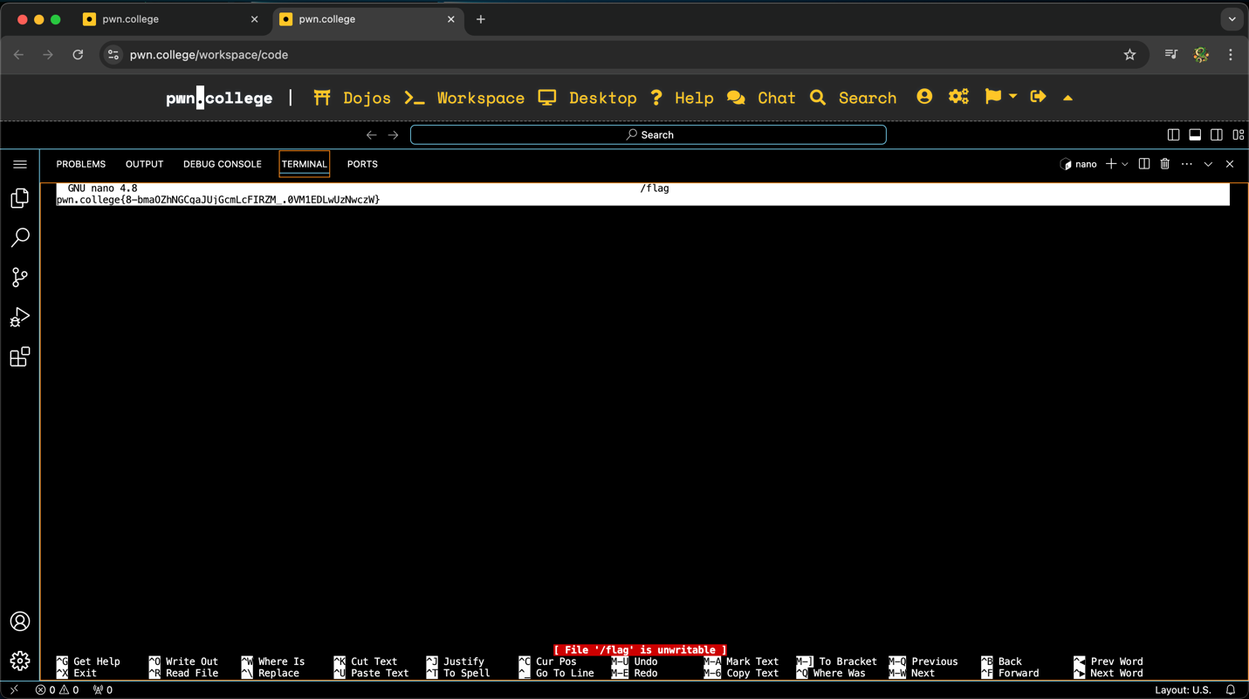
To obtain this flag, I started the challenge and opened the VSCode Workspace. This is the final challenge where I am unable to provide a screenshot showing both the commands used and the flag due to the nature of the challenge. This time, the flag was in /challenge/bin/nano. I am familiar with the nano command, as I used it in past labs. The nano command allows users to create/open a file that can be edited by the user. After entering /challenge/bin/nano /flag, this opened the file containing the flag.

Challenge 10: level10
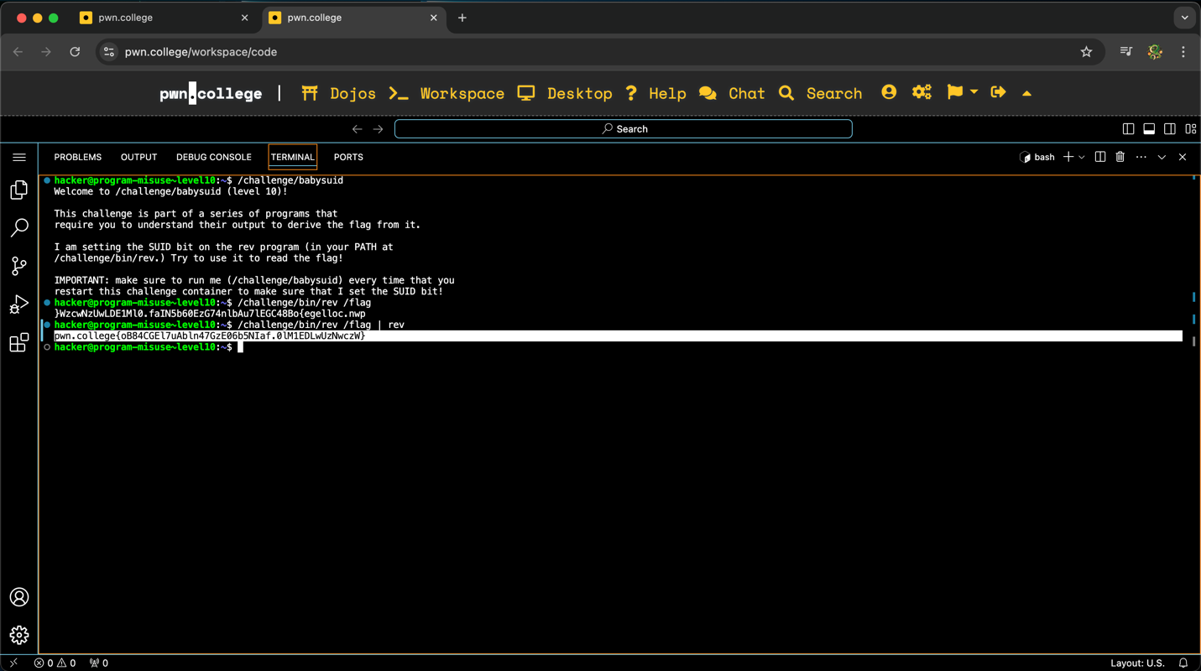
To obtain this flag, I started the challenge and opened the VSCode Workspace. Up to this point, the challenges have been simple, but these next set of challenges would transform the flag in special ways. After starting the program, the welcome message informed me the flag was in /challenge/bin/rev. Like all other challenged, I proceeded by typing /challenge/bin/rev /flag, which revealed the flag, but backwards. This allowed me to realize the rev command is short for reverse, which explained why the flag was reversed. I could have manually entered the flag by entering the characters in the reverse order seen on screen, but I decided to use the rev command to reverse the reversed flag (which would undo the transformation). I did this by typing /challenge/bin/rev /flag | rev, which printed the flag in the correct order.

Challenge 11: level11
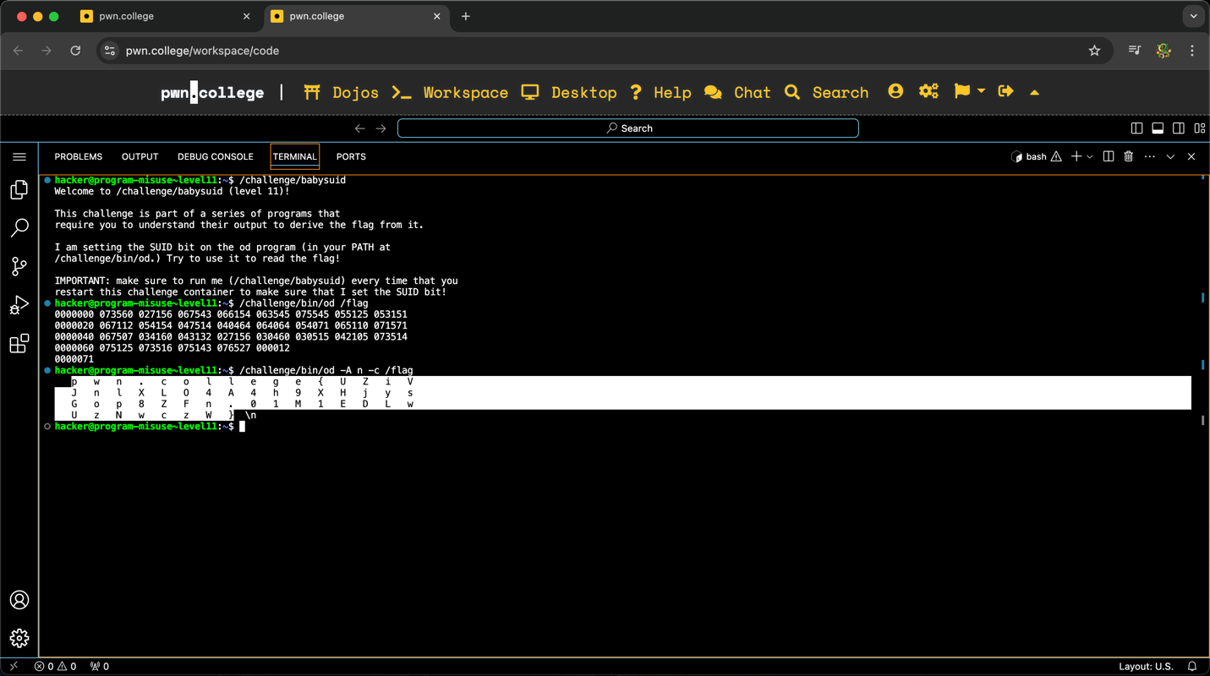
To obtain this flag, I started the challenge and opened the VSCode Workspace. I started the challenge by typing /challenge/babysuid, which revealed to me the flag was in the /challenge/bin/od directory. I did not recognize the od command, but proceeded by entering /challenge/bin/od flag. This time, a long set of numbers was printed. I suspect these numbers represent octal values of the flag. To translate the numbers back to the flag, I entered /challenge/bin/od -A n -c flag. These arguments resulted in the flag being printed one character at a time.

Challenge 12: level12
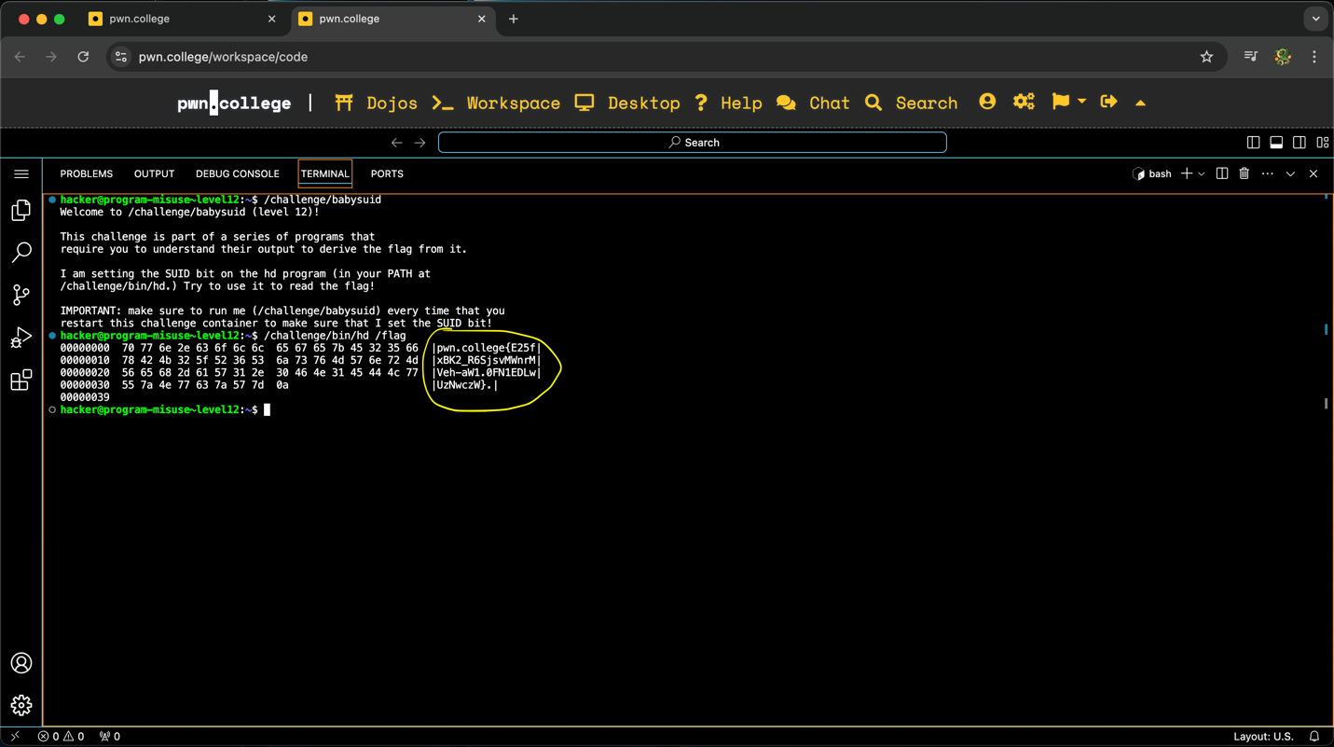
To obtain this flag, I started the challenge and opened the VSCode Workspace. The flag was stored in the /challenge/bin/hd, where I soon learned this challenge has similarities to the previous one. After typing /challenge/bin/hd /flag in the terminal, a series of hex values were printed, along with chunks of the flag to the right side. I manually put together the chunks to recreate the flag.

Challenge 13: level13
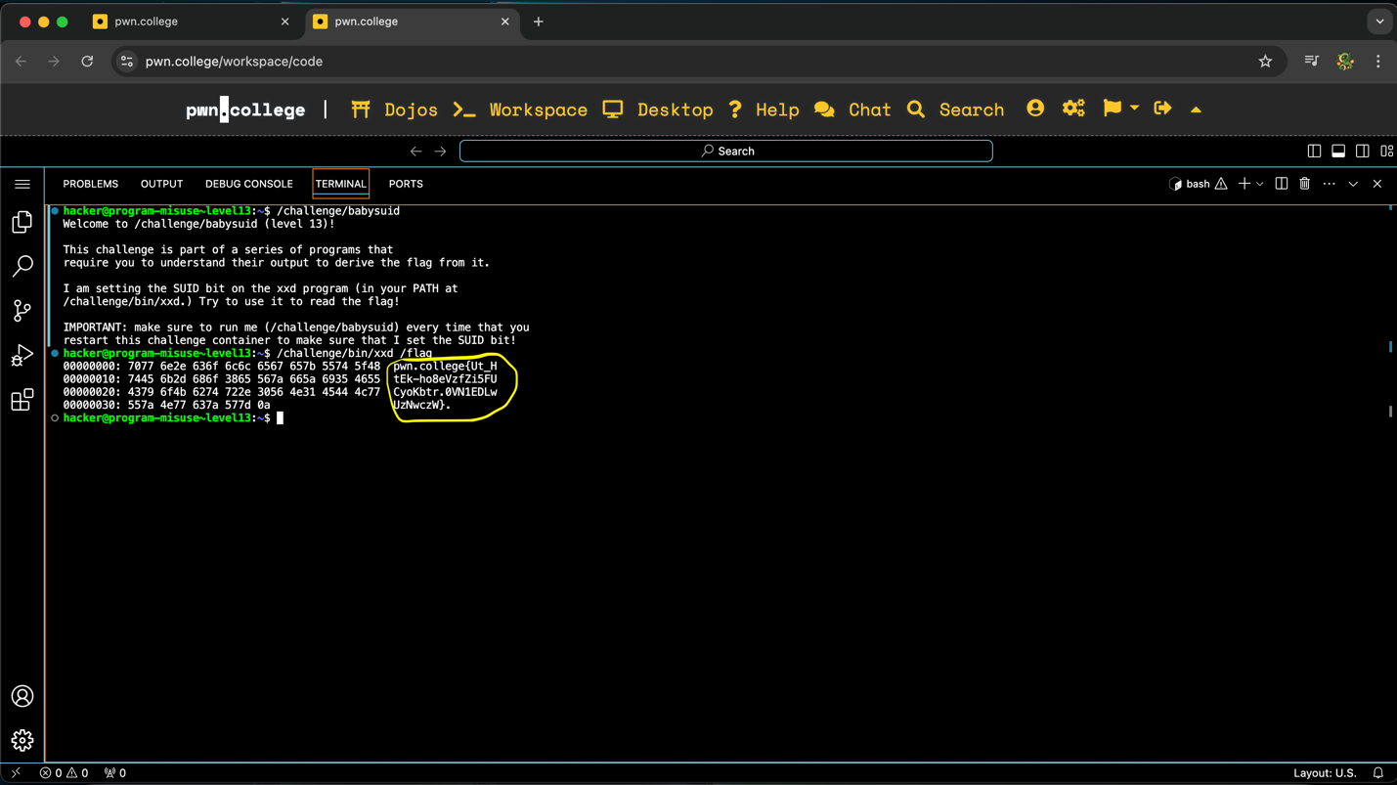
To obtain this flag, I started the challenge and opened the VSCode Workspace. The welcome screen for this challenge revealed to me the flag was in /challenge/bin/xxd. I am also unfamiliar with xxd, but personal research revealed it is nearly identical to hexadecimal transformation with the only notable difference being that hexadecimal values are stored in groups of four rather than two. I proceeded by entering /challenge/bin/xxd /flag in the terminal. Like the last challenge, this resulted in the terminal printing a series of hexadecimal values on the left and chunks of the actual flag on the right. Finally, I manually put together the chunks of the flag and submitted it to the website.

Challenge 14: level14
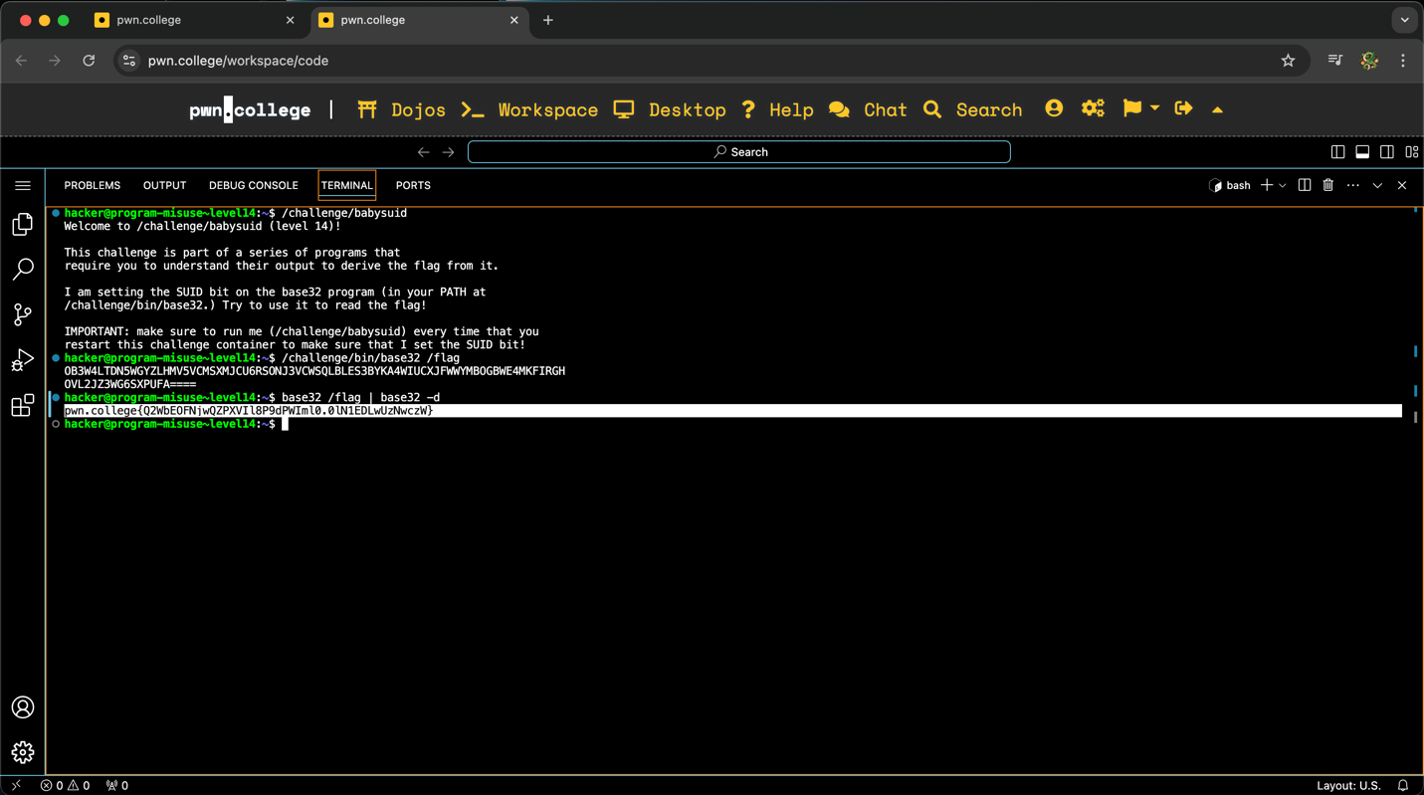
To obtain this flag, I started the challenge and opened the VSCode Workspace. The welcome screen for this challenge revealed the flag was stored in /challenge/bin/base32. This information was critical because the naming of the directory implies the flag was encrypted using base32. I proceeded by entering /challenge/bin/base32 /flag, and the terminal printed the flag encrypted in base32. The key to solving this challenge would be knowing how to decrypt base32. With some individual research, I learned I could decrypt the flag by typing base32 /flag | base32 -d in the terminal, which decrypted the flag in its original form.

Challenge 15: level15
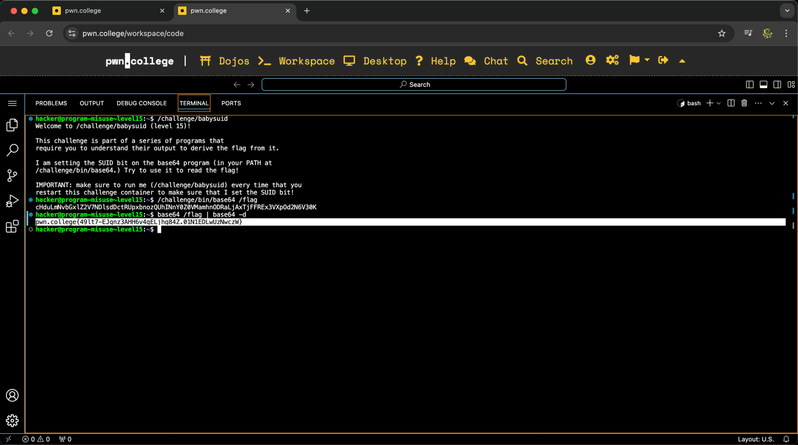
To obtain this flag, I started the challenge and opened the VSCode Workspace. This challenge is nearly identical to the last one, with the only difference being that the flag was encrypted using base64 rather than base32. I followed the exact same steps as I did in the last challenge but change every instance of 32 to 64. This included the directory to the flag, and the command to decrypt the message. In the end, I decrypted the flag.

